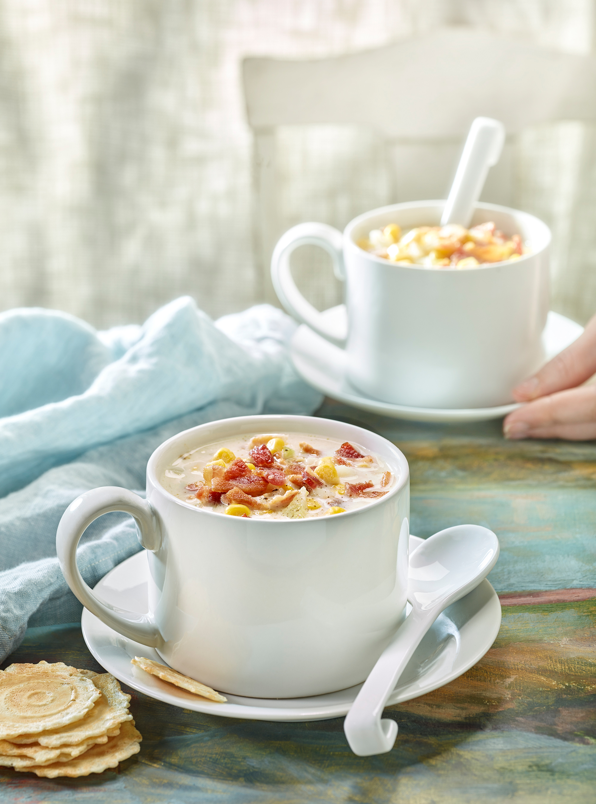
LIZA RUDOLPH STYLIST SET DECORATOR
7690 Berkshire Pkwy Manlius, NY 13104
ph/tx: 310-779-8103 Email: Liza.rudolph@gmail.com
Website Address: http://www.lizarudolph.com

PROFILE: I have extensive experience in still-life photography and in decorating for the film and television industry. I am creative, organized, and self-motivated. I anticipate needs and take pride in team collaboration. I am a maker and a doer, and I am ready to answer any challenge

EDUCATION:
Painting and Printmaking, BFA Syracuse University School of Art, Summa cum Laude

POSITIONS HELD:

- Food & Still Life Photo Stylist
- Set Decorator
- Assistant Set Decorator
- Textile Designer/Manufacturer
- Set Decorating Buyer
- Art Department Coordinator

CORE RESPONSIBILITIES

- Interpret and enhance the creative vision and the storyline of a project.
- Clearly communicate aesthetic proposals and execute.
- Estimate budget costs and labor needs.
- Research environment, character, visual history, and decorative style.
- Maintain strong relationships with outside creative services.
- Work quickly, independently, and resourcefully.
- Establish information files including, photos, drawings, research, and schedules.
- Seamlessly juggle what’s ahead while working on what’s now.
- Meet deadlines and adjust to a constantly changing environment.
- Read and interpret plans and elevations.

ADDITIONAL SKILLS AND INTERESTS:
Adobe Illustrator, Photoshop, InDesign; Microsoft Office; Pages, Numbers, Aperture; Google Sketch Up, Mac and PC. Costume design/tailoring, organic gardening, woodworking, writing and fine arts, White House Christmas Decorating Invited Volunteer.

SELECTED PROJECTS:

Salem
HBO-Luck
Alice in Wonderland*
Race to Witch Mountain,
Indiana Jones/Crystal Skull
Transformers
Memoirs of a Geisha*
Christmas with the Kranks
The Last Samurai**
Master and Commander**
The Patriot
Moonlight Mile
Planet of the Apes
Message in a Bottle
The Game
Yahoo
Verizon
Peugeot
Toyota
Wendy’s
Pepsi
Fancy Feast
LL Bean
Sperry Top Siders
Sturbridge Yankee Workshop
Norwegian Seafood
Yankee Magazine
Wild Blueberry Association of North America
Dean Food

*Oscar winner Best Art Direction ** Oscar nominated Best Art Direction

References available on request

